Page 1 of 6 MIT (Assignment – 4)

U20CS110
Krishna Pandey

(1). Write an assembly language program in 8085 to search a given number in an array of n numbers. If number is found, then store AA in memory location 4051 otherwise store BB in 4051.

;<Question-1>

JMP start

start: LXI H, 2050H

MOV B, M

INX H

MOV C, M

skip: INX H

MOV A, M

CMP B

JZ loop

DCR C

JNZ skip

MVI A, BBH

STA 4051H

HLT

loop: MVI A, AAH

STA 4051H

HLT
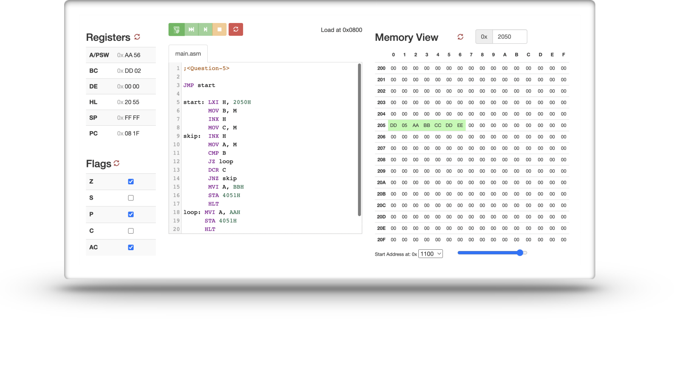
Page 2 of 6 Krishna Pandey (U20CS110) ASSIGNMENT - 04
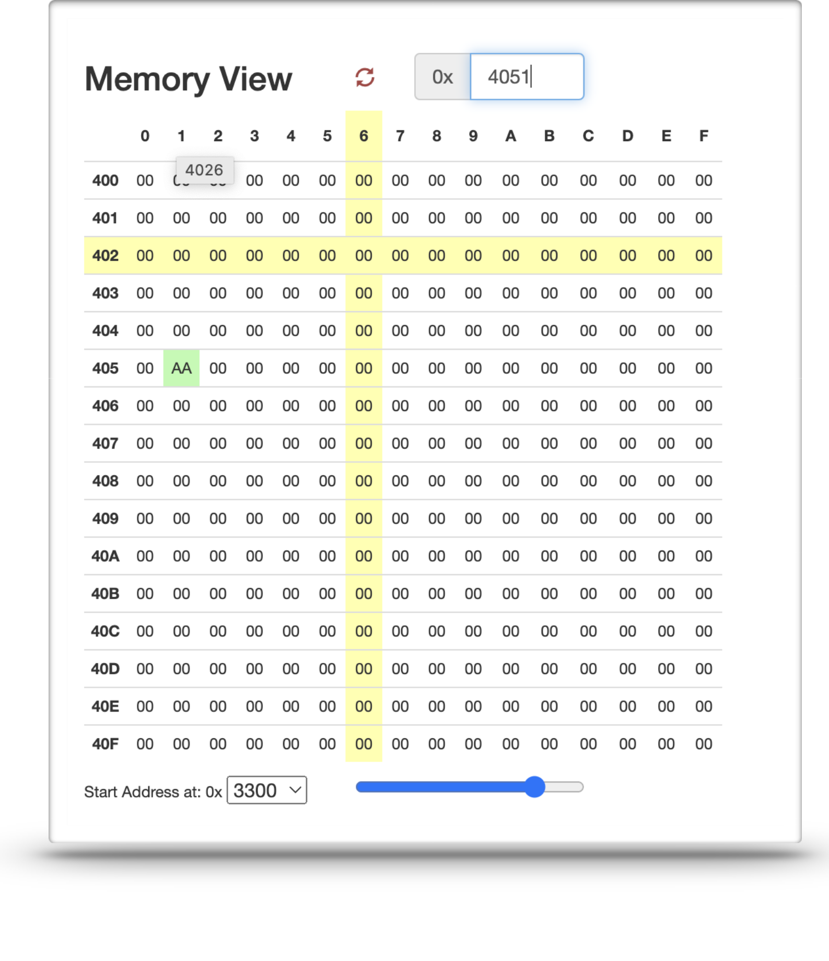
Page 3 of 6 Krishna Pandey (U20CS110) ASSIGNMENT - 04

(2).Write an assembly language program to sort numbers in ascending order where six numbers are stored in consecutive memory locations starting from 2000H.

;<Question-2>

JMP START

START: LXI H, 2000H

MVI D, 00H

MOV C, M

DCR C

INX H

CHECK: MOV A, M

INX H

CMP M

JC NEXTBYTE

JZ NEXTBYTE

MOV B, M

MOV M, A

DCX H

MOV M, B

INX H

MVI D,01H

NEXTBYTE: DCR C

JNZ CHECK

MOV A, D

CPI 01H

JZ START

HLT
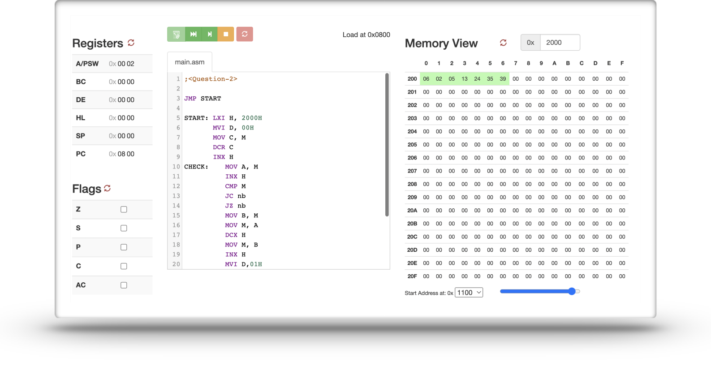
Page 4 of 6 Krishna Pandey (U20CS110) ASSIGNMENT - 04

(3).Write an assembly language program to take all numbers which are not 00H from array, and store them into different location. Numbers are stored at 3001 onwards, 3000 is holding the size of array, the results will be stored from 4000.

;<Question-3>

JMP START

START: LXI H,3000H

MOV C,M

LXI D,4000H

LOOP: INX H

MOV A,M

ORI 00H

JZ SKIP

STAX D

INX D

SKIP: DCR C

JNZ LOOP

HLT
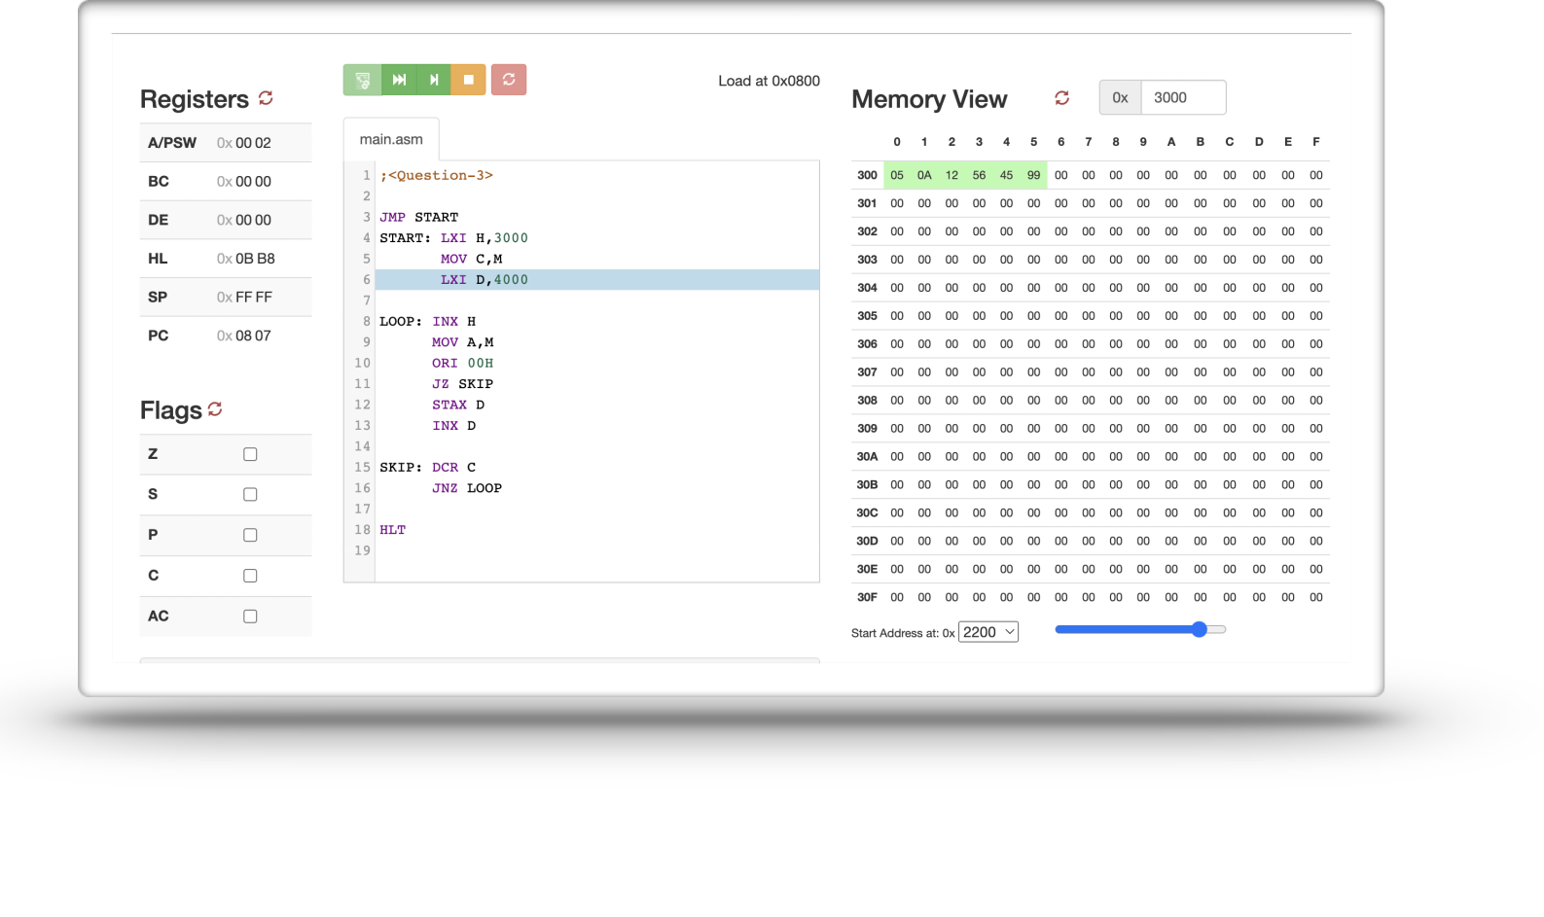
Page 5 of 6 Krishna Pandey (U20CS110) ASSIGNMENT - 04
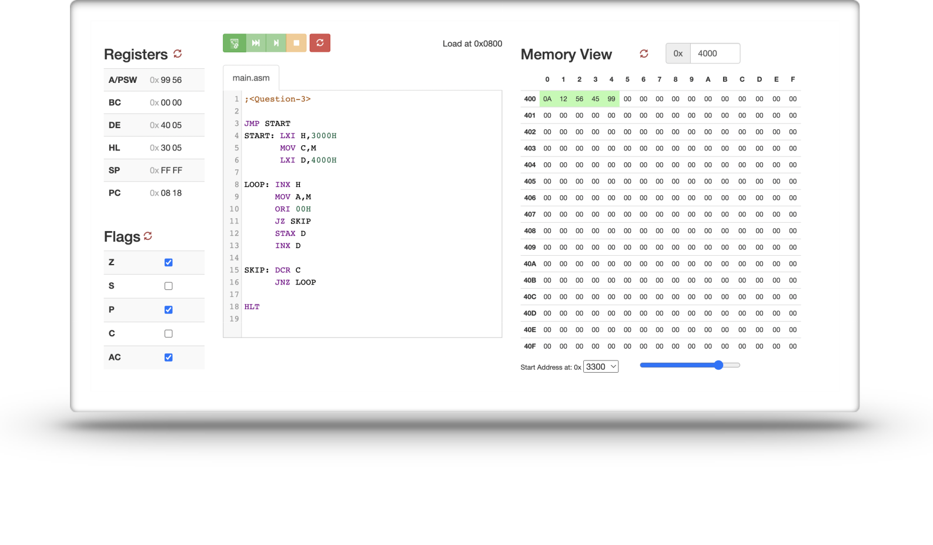
Page 6 of 6 Krishna Pandey (U20CS110) ASSIGNMENT - 04

(4).Write an assembly language program to insert a new value in an array of data only if it is not present in the array. Assume suitable data and memory location.

;<Question-4>

JMP start

start: LXI H, 0000H

MOV B, M

INX H

MOV C, M

skip: INX H

MOV A, M

CMP B

JZ loop

DCR C

JNZ skip

MOV A, B

STA 0007H

HLT

loop: HLT
